PRIME FACTORS, HCF AND LCM
Pearson Edexcel - Tuesday 21 May 2019 - Paper 1 (Non-Calculator) Higher Tier
1.
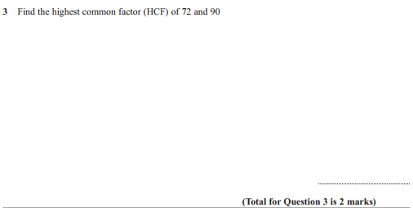

Pearson Edexcel - Thursday 7 June 2018 - Paper 2 (Calculator) Higher Tier
2.
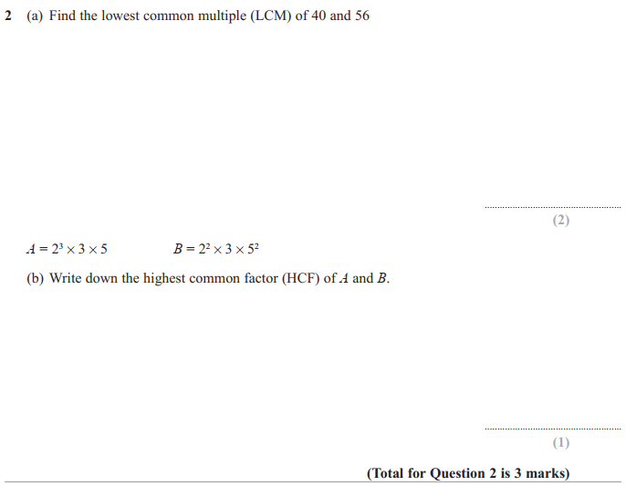
Pearson Edexcel - Specimen Papers Set 2 - Paper 3 (Calculator) Higher Tier
3.
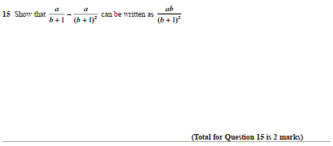

Pearson Edexcel - Wednesday 5 November 2014 - Paper 1 (Non-Calculator) Higher Tier
4.
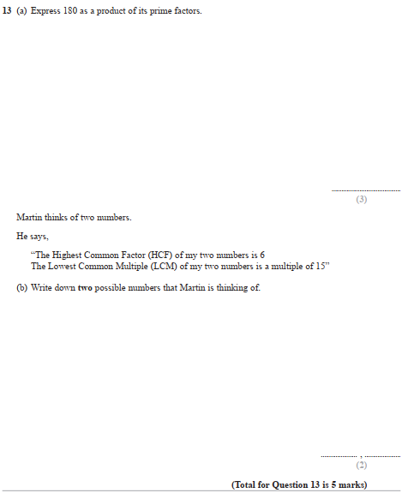

Pearson Edexcel - Monday 14 November 2011 - Paper 4 (Calculator) Higher Tier
5.
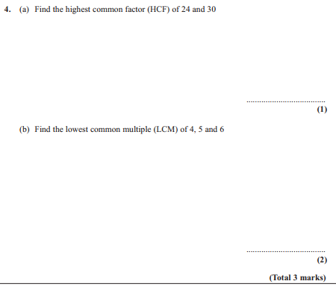

Pearson Edexcel - Friday 10 June 2011 - Paper 4 (Calculator) Higher Tier
6.
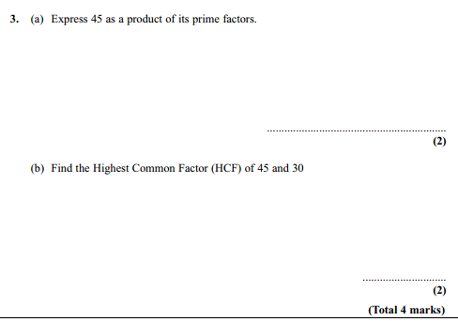
Pearson Edexcel - Friday 12 November 2010 - Paper 4 (Calculator) Higher Tier
7.
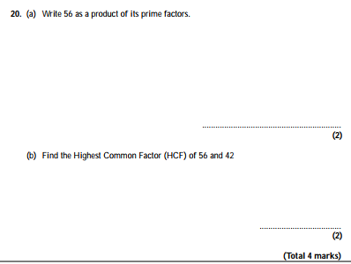
OCR GSCE – Tuesday 5 November 2019 – Paper 4 (Calculator) Higher Tier
8.
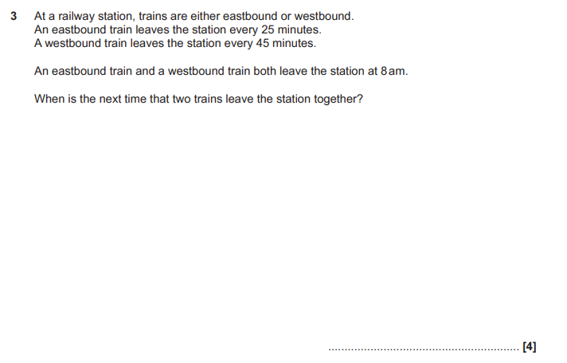

OCR GSCE – Thursday 7 November 2019 – Paper 5 (Non-Calculator) Higher Tier
9.
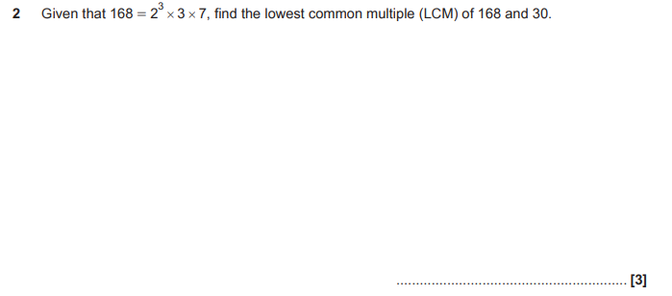

OCR GSCE – Tuesday 11 June 2019 – Paper 6 (Calculator) Higher Tier
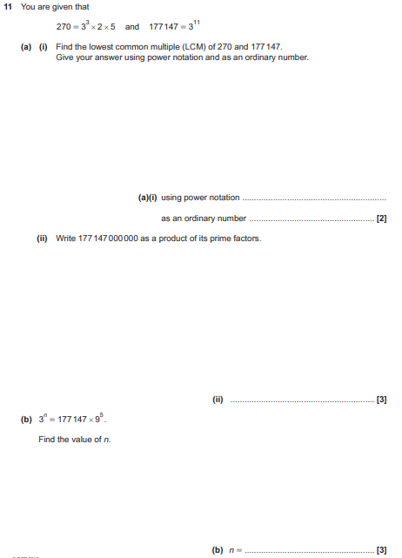

OCR GSCE – Tuesday 6 November 2018 – Paper 4 (Calculator) Higher Tier
11.
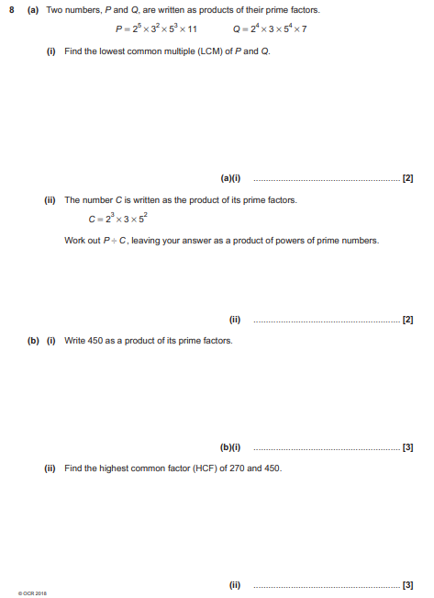

OCR GSCE – Thursday 24 May 2018 – Paper 4 (Calculator) Higher Tier
12.
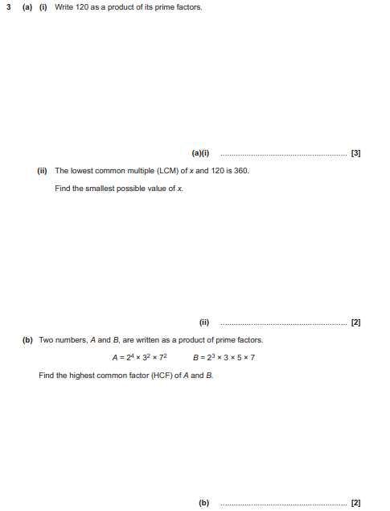

OCR GSCE – Thursday 25 May 2017 – Paper 4 (Calculator) Higher Tier
13.
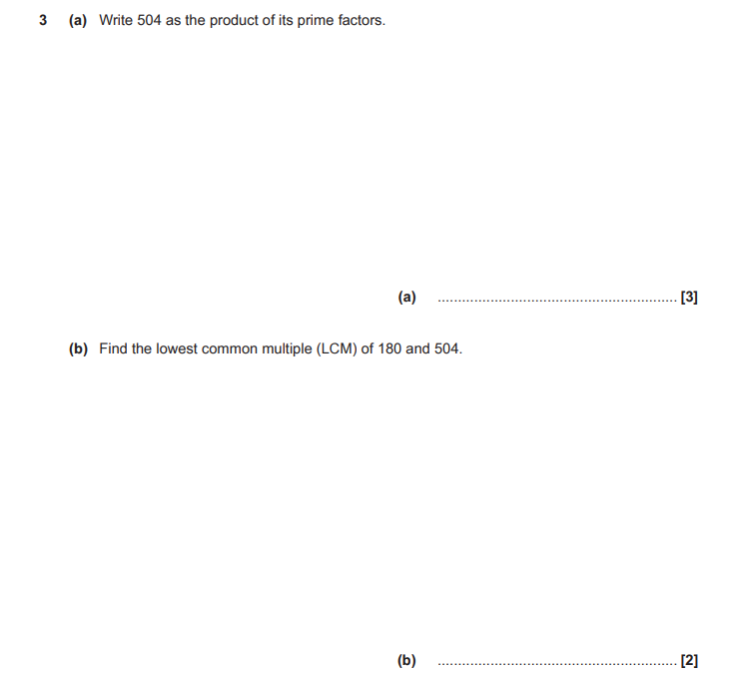

AQA GSCE – Thursday 4 June 2020 – Paper 2 (Calculator) Higher Tier
14.
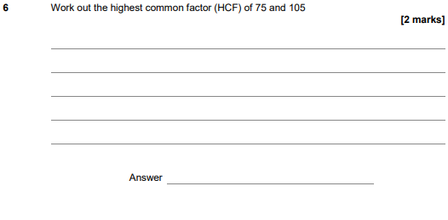
15.
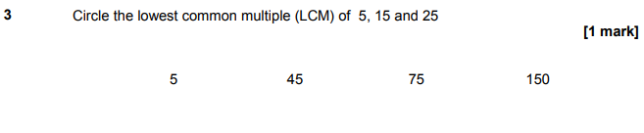

AQA GSCE – Monday 12 November 2018 – Paper 3 (Calculator) Higher Tier
16.
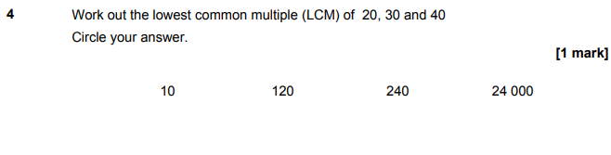
AQA GSCE – Tuesday 12 June 2018 – Paper 3 (Calculator) Higher Tier
17.
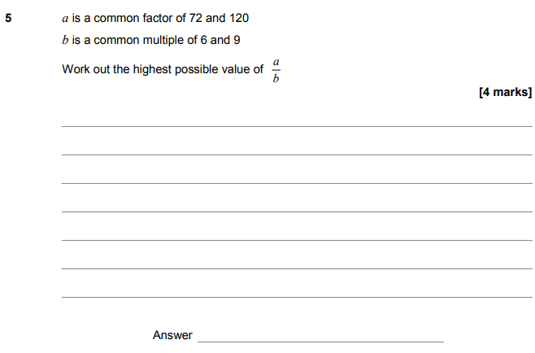

AQA GSCE – Wednesday 8 November 2017 – Paper 3 (Calculator) Higher Tier
18.
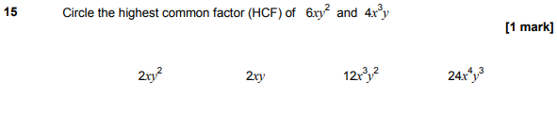
AQA GSCE – Wednesday 8 November 2017 – Paper 3 (Calculator) Higher Tier
19.
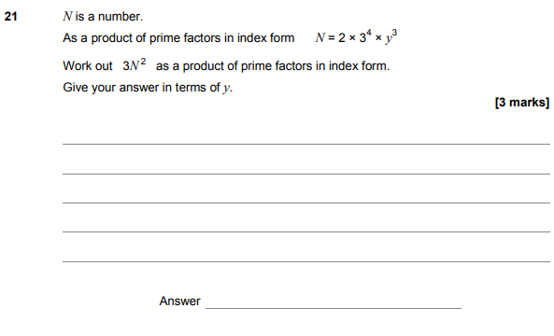

AQA GSCE – Wednesday 25 May 2017 – Paper 1 (Non - Calculator) Higher Tier
20.
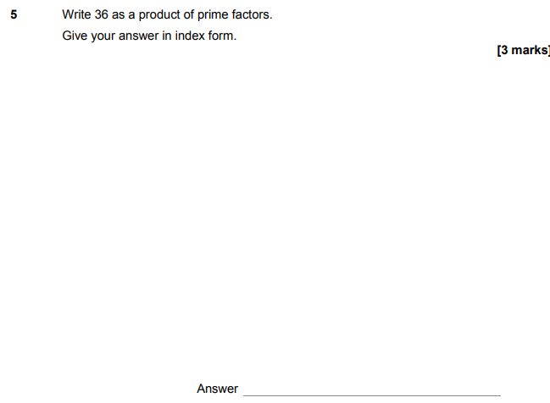

AQA GSCE – Sample Paper 2 (Calculator) Higher Tier
21.
